
Astana IT University
Subject: Industry 4.0
Instructor: Alimzhan Yessenov
Student name: Latip Medet
Group: ST-2303

Assignment 2
IoT Sensor Data Collection & Visualization

IoT Light Sensor Monitoring System
This report describes the design, implementation, and evaluation of an Internet of Things (IoT) light sensor monitoring system developed using Python and Google Colab. The system demonstrates a complete IoT data pipeline, including data generation, communication via the MQTT protocol, data preprocessing, visualization, and threshold-based alerting. The project is intended as an educational prototype that reflects modern IoT architectural principles.

1. Introduction
The Internet of Things (IoT) refers to a network of interconnected devices capable of collecting, transmitting, and processing data without direct human intervention. IoT systems are widely used in smart homes, industrial automation, healthcare, environmental monitoring, and smart cities. One important application area is light monitoring, which helps optimize energy consumption, improve user comfort, and ensure safety in indoor and outdoor environments.
The objective of this project is to design and implement a cloud-based IoT light monitoring system that collects illumination data, transmits it using a lightweight protocol, processes the data, and visualizes it through an interactive dashboard. The system also detects abnormal lighting conditions using predefined thresholds and generates alerts.

2. System Architecture
The proposed system follows a layered IoT architecture consisting of four horizontal layers: perception, transport, preprocessing, and application. This architectural approach improves modularity, scalability, and clarity by separating responsibilities across different layers.
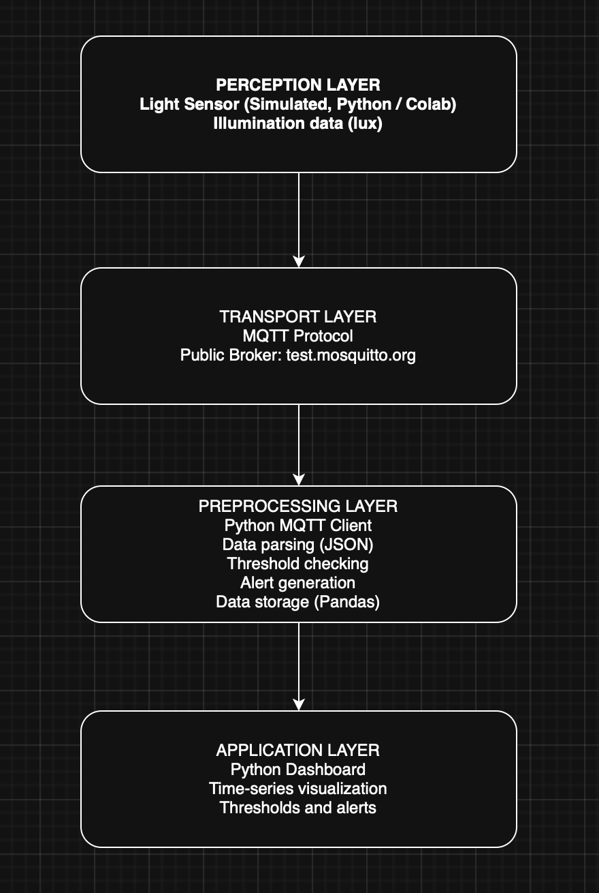
Figure 1 presents the overall architecture of the IoT light sensor monitoring system. The perception layer is responsible for data acquisition and simulates a light sensor using Python in Google Colab, generating illumination values measured in lux. The transport layer handles data transmission using the MQTT protocol and a public broker. The preprocessing layer receives MQTT messages, parses the data, performs threshold checking, generates alerts, and stores the data in a Pandas DataFrame. Finally, the application layer visualizes the processed data using a Python-based dashboard.

3. Data Collection and Communication
In this project, light sensor data is simulated to represent a real-world illumination sensor. Random values within a realistic lux range are generated periodically to emulate sensor readings. This approach allows the system to be tested without requiring physical hardware.
The Message Queuing Telemetry Transport (MQTT) protocol is used for data communication. MQTT is a lightweight publish-subscribe protocol designed for constrained devices and low-bandwidth networks. Sensor data is published to a public MQTT broker under a specific topic, allowing subscribers to receive the data asynchronously.

4. Data Processing and Visualization
The preprocessing layer plays a crucial role in transforming raw sensor data into meaningful information. Incoming MQTT messages are parsed from JSON format and stored in a structured Pandas DataFrame. Threshold values are defined to classify lighting conditions as low, normal, or high.
The application layer provides a visual dashboard that displays light intensity as a time-series graph. Threshold lines are shown on the dashboard, and alert points are highlighted when the measured values exceed predefined limits. This visualization enables users to quickly identify abnormal lighting conditions.

5. Thresholds and Alerts
Threshold-based monitoring is a common technique in IoT systems. In this project, lower and upper lux thresholds are defined to represent insufficient and excessive lighting conditions. When sensor readings fall outside the acceptable range, alerts are generated and highlighted on the dashboard.
Such alert mechanisms are essential in real-world IoT applications, as they enable proactive responses to abnormal conditions. For example, alerts can trigger automated lighting control, energy-saving measures, or user notifications.

6. Conclusion
This project demonstrates the successful implementation of an IoT light sensor monitoring system using Python, MQTT, and cloud-based tools. The system illustrates how IoT data can be collected, transmitted, processed, and visualized in a modular and scalable manner.
Future work may include integrating real hardware sensors, storing data in a cloud database, deploying the system on edge devices, and implementing automated notifications via email or mobile applications.

7. References
- Al-Fuqaha, A., Guizani, M., Mohammadi, M., Aledhari, M., & Ayyash, M. (2015). Internet of Things: A survey on enabling technologies, protocols, and applications. IEEE Communications Surveys & Tutorials, 17(4), 2347–2376.
- Banks, A., & Gupta, R. (2014). MQTT Version 3.1.1. OASIS Standard.
- Gubbi, J., Buyya, R., Marusic, S., & Palaniswami, M. (2013). Internet of Things (IoT): A vision, architectural elements, and future directions. Future Generation Computer Systems, 29(7), 1645–1660.
- Pandas Development Team. (2023). Pandas documentation. https://pandas.pydata.org/
- Matplotlib Development Team. (2023). Matplotlib documentation. https://matplotlib.org/

Colab: https://colab.research.google.com/drive/1KTDB6lPm0-Fy_vfnVcVAvwQtF0wKGOYn#scrollTo=jAXayzlNQwmZ

